**FIGURE LEGENDS**

**Figure 1:** Cohort Design Flow

Figure 1A

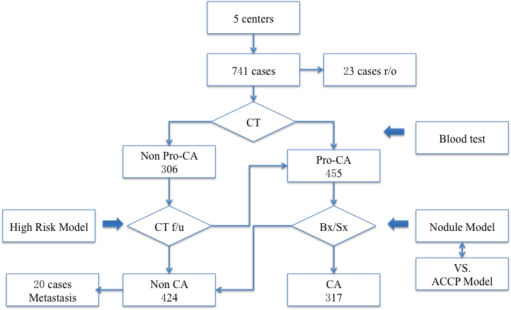

Figure 1B



**Figure 2**



**Figure 3:** ROC comparison between LCBP and ACCP lung nodule model

Figure 3



**Figure 4:** Comparison of diagnostic efficacy of LCBP vs. ACCP on high risk stratification of lung nodule patients

Figure 4